14.35: The assumption may be taken to mean that 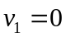in Eq. (14.17). At the maximum height,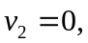 and using gauge pressure for 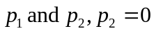(the water is open to the atmosphere), 